[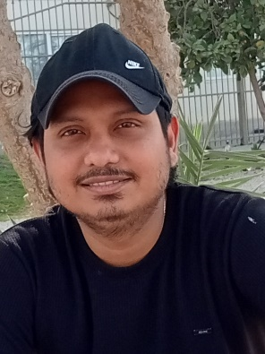](https://www.linkedin.com/in/praneeth-hapuarachchi-b903145b/)PRANEETH MAHANAMA HAPUARACHCHI

# Contact Information

+971 547561974



[praneeth.hapuarpraneeth.hapuarachchi@gmail.com](mailto:praneeth.hapuarachchi@gmail.com)

Passport No & Validity: N8147074 23/01/2029

[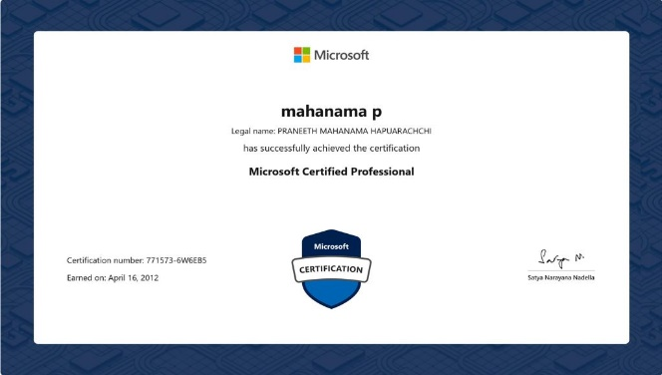](https://learn.microsoft.com/en-us/users/mahanamap-7049/transcript/vpr33igje5p5gjk?source=docs)

Name in Full : Praneeth Mahanama Hapuarachchi

Date of Birth : 08/01/1989

Sex : Male

Material Status : Single Nationality : Sri Lankan

# Employment History

## Mountain Gate Property Investment LLC, Abu Dhabi

IT Support Engineer

April 2020 Present

* Provide IT support to company staﬀ.
* Setting up and installing PCs, Applications, Network and Software.
* Maintain the Wi-Fi facility in order to provide good connection to the

wireless customers.

* Installing and conﬁguring O/S, Antivirus, other applications, etc.
* Keeping a record of issues and faults along with solutions for future references.
* Planning and undertaking scheduled maintenance updates, upgrades.
* Keeping eye on Systems performance, breakdowns, etc.
* Manage and maintain Hikvision IVMS CCTV, NVR, Biometric etc.
* Remote support through team viewer, any desk, ammy admin, zoho

to branch users.

* Diagnose and troubleshoot technical issues (Network, Hard ware,

Software).

* Secure all pcs with latest antivirus security patches.
* Understanding on Virtual desktop environment (Citrix, VM Ware, Oracle Virtual Box, Hyper-V)
* MS Office suites installation, configuring and troubleshooting outlook etc.
* Configuring and maintaining TP-Link routers, access points and Omada cloud.

***Selco Continental (PVT) LTD, Sri Lanka***

IT Executive

February 2019 – June 2019

* Setting up and authorizing software, hardware, and server resources for new users.
* Installing and troubleshooting software, networking, printers, scanners etc.
* Installing high-level software security systems.
* Training staﬀ on basic IT functions.
* Respond to general IT requests.
* Ensuring security software is kept up to date.
* Collaborate with various departments and stakeholders to assess IT needs.
* Support End user device like laptop, desktop, printer troubleshooting.

## Ceylon Beverages Can (PVT) LTD, Sri Lanka

IT Executive

August 2017 – December 2018

- CCTV, Biometric, Routers, Switches configuration and maintenance etc.

* + Coordinate with company website hosting provider and domain E-mail provider if any issues.
  + Logging and processing support calls.
  + Installing & conﬁguring computer hardware, software, systems, networks, printers and scanners.
  + Planning and undertaking scheduled maintenance upgrades.
  + Setting up user accounts, ensure they know how to log in and solve password problems.
  + Respond to breakdowns.
  + Configuring and maintaining enterprise backup Acronis, Norton Ghost, EaseUS Todo

***DHL Keells (PVT) LTD, Sri Lanka***

E-Commerce Helpdesk Executive

March 2017 – August 2017

- Manage CCTV and Finger Print Access Devices.

* + Train staﬀ on newly installed hardware & software systems.
  + Respond to general IT requests.
  + Logging and processing support calls, helpdesk tickets.
  + Respond to breakdowns.
  + Planning and undertaking scheduled maintenance upgrades.
  + Maintain records of software licenses and all IT devices inventory.

***LankaCom Services (PVT) LTD, Sri Lanka***

Network Administrator

March 2015 – September 2016

- Manage and maintain Finger Print Access Devices.

* + Investigate diagnose and solve computer hardware, software and networking faults.
  + Checkup computer equipment for electrical safety.
  + Repair computer equipment and replace parts.
  + Install and conﬁgure computer hardware, operating systems and applications.
  + Support rolls out of new applications.
  + Maintain MS Exchange, MS Internet Server Acceleration (ISA Firewall)

***BPO Connect (PVT) LTD, Sri Lanka***

Junior Network Administrator

July 2013 – September 2014

- Monitor and maintain computer system and network.

* + Troubleshoot computer system and network problems.
  + Provide support including procedural documentation and relevant reports.
  + Work continuously on a task until completion.
  + Setting up user accounts, E-mail conﬁguration etc.
  + Monitor system performance.
  + Manage Engine ticketing system.
  + Manage and maintain DNS server, DHCP server, MS Exchange.

***DMS Software Engineering (PVT) LTD, Sri Lanka***

Trainee System Administrator / System Administrator

May 2011 – December 2012

- Active Directory user administration.

* + Maintain computer systems, servers, hardware, network, disk space, memory and software components.
  + Monitor server security (Change Admin Password, Setup User Policies, etc.
  + Quickly arrange repair for hardware in occasion of hardware and equipment failure.
  + Create archival process, perform archival of the data and maintain the archival library.
  + Perform Backup / Restore as per the company policy.

## MONARO Security Services (PVT) LTD, Sri Lanka

IT Assistant

June 2010 – April 2011

- Maintain Antivirus software and updates for all servers and client machines.

* + Verify that the peripherals are working properly.
  + Install and conﬁgure new Hardware, Software.
  + Prioritize and mange open cases.
  + Rapidly establish good work relationship with users, customers.
  + Respond to Helpdesk calls.
  + Follow diagrams, written instructions to repair a fault or set up new system.
  + Perform HP tape backups and restore in case of data lost, disaster recovery etc.
* Microsoft Certified Professional with 10 yrs. experience (7.5Yrs Sri Lanka, 3.3Yr Abu Dhabi)

# Educational Qualiﬁcations

* Microsoft Certified Professional.
* Diploma in Computer Hardware and Networking
* Certiﬁcate in Information Technology
* Certiﬁcate in Hardware Engineering and Networking at Open University Sri Lanka
* Diploma in Windows Network Administration
* Cisco IT Essential – ITE (PC Hardware and Networking)
* Cisco Certiﬁed Network Associate (Academic) at Cisco Networking Academy, Vocational

Training Authority, Sri Lanka

* MS 6292 – Installing & Conﬁguring Windows 7 Client
* MS 6421 – Conﬁguring & Troubleshooting Windows Server 2008 Network Infrastructure
* Computerized Accounting Package
* Certiﬁcate in English (Higher Level) at University of Colombo, Sri Lanka
* English Diploma Course at Aquinas College, Sri Lanka

I certify that the above information and particulars of mine are true and correct to the best of my knowledge

Yours Faithfully,

## Praneeth Hapuarachchi